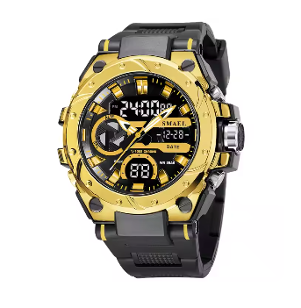

### Product Name: **CURREN Men's Luxury Quartz Watch**

### Description:

This watch features an **analog display** with a **sleek black dial**, a **stainless steel case**, and a **brown leather strap**, giving it a refined and modern appearance. The classic quartz movement ensures accurate timekeeping, while the minimalistic yet bold design enhances its luxurious feel.

### Specifications:

* **Brand:** CURREN
* **Display Type:** Analog
* **Movement:** Quartz
* **Case Material:** Stainless Steel
* **Strap Material:** Leather
* **Water Resistance:** Resistant to light splashes and rain
* **Functions:** Time, Date
* **Dial Color:** Black
* **Strap Color:** Brown

### Price:

$25 to $50